**Practical 1A**

**Aim:**  Create a simple Calculator application using servlet.

**Program Code:**

***Index.html***

<?xml version='1.0' encoding='UTF-8' ?>

<!DOCTYPE html PUBLIC "-//W3C//DTD XHTML 1.0 Transitional//EN" "http://www.w3.org/TR/xhtml1/DTD/xhtml1-transitional.dtd">

<html xmlns="http://www.w3.org/1999/xhtml"

xmlns:h="http://xmlns.jcp.org/jsf/html">

<head>

<title>Calculator</title>

</head>

<body>

<form action="CalculatorServlet">

Enter a first Number

<input type="text" name ="txt1"> </input><br></br>

Enter a Second Number

<input type="text" name ="txt2"> </input><br></br>

<br></br>select a operation

<select name="opr">

<option value="+">+</option>

<option value="-">-</option>

<option value="*">*</option>

<option value="/">/</option>

</select>

<!--<input type="radio" name="opr" value="+">Add</input>

<input type="radio" name="opr" value="*">multiply</input>

<input type="radio" name="opr" value="/">division</input>

<input type="radio" name="opr" value="-">subtraction</input><br></br><br></br>-->

<input type="reset" value="reset"></input>

<input type="submit" value="calculate"></input>

</form>

</body>

</html>

**CalculatorServlet.java**

package mypack;

import java.io.IOException;

import java.io.PrintWriter;

import javax.servlet.ServletException;

import javax.servlet.http.HttpServlet;

import javax.servlet.http.HttpServletRequest;

import javax.servlet.http.HttpServletResponse;

public class CalculatorServlet extends HttpServlet {

protected void processRequest(HttpServletRequest request, HttpServletResponse response)

throws ServletException, IOException

{

response.setContentType("text/html;charset=UTF-8");

PrintWriter out = response.getWriter();

try {

out.println("<!DOCTYPE html>");

out.println("<html>");

out.println("<head>");

out.println("<title>Servlet CalculatorServlet</title>");

out.println("</head>");

out.println("<body>");

double n1 = Double.parseDouble(request.getParameter("txt1"));

double n2 = Double.parseDouble(request.getParameter("txt2"));

double result = 0;

String opr = request.getParameter("opr");

if(opr.equals("+")) result = n1+n2;

if(opr.equals("-")) result = n1-n2;

if(opr.equals("*")) result = n1*n2;

if(opr.equals("/")) result = n1/n2;

out.println("<h1> Result : " + result + "</h1>");

out.println("</body>");

out.println("</html>");

} finally {

out.close();

}

}

}

**Output:**

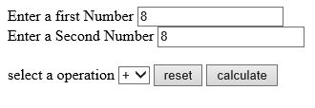



**Practical 1B**

**Aim**: Create a servlet for a login page. If the username and password are correct then it says message “Hello” else a message “login failed”.

**Program:**

***Index.html***

<!--

To change this template, choose Tools | Templates

and open the template in the editor.

-->

<!DOCTYPE html>

<html>

<head>

<title></title>

<meta http-equiv="Content-Type" content="text/html; charset=UTF-8">

</head>

<body>

<form action="ValidateServlet">

Enter username:

<input type="text" name="usr" ><br>

Enter password:

<input type="text" name="pass" ><br>

<input type="submit" value="submit">

</form>

</body>

</html>Top of Form

***ValidateServlet.java***

import java.io.IOException;

import java.io.PrintWriter;

import javax.servlet.ServletException;

import javax.servlet.annotation.WebServlet;

import javax.servlet.http.HttpServlet;

import javax.servlet.http.HttpServletRequest;

import javax.servlet.http.HttpServletResponse;

public class ValidateServlet extends HttpServlet {

protected void processRequest(HttpServletRequest request, HttpServletResponse response)

throws ServletException, IOException

{

response.setContentType("text/html;charset=UTF-8");

PrintWriter out = response.getWriter();

try {

out.println("<!DOCTYPE html>");

out.println("<html>");

out.println("<head>");

out.println("<title>Servlet ValidateServlet</title>");

out.println("</head>");

out.println("<body>");

String username = "abc";

String password = "123";

String usr1 = request.getParameter("usr");

String pass1 = request.getParameter("pass");

if((username.equals(usr1)) && (password.equals(pass1))) {

out.println("<h1> hello " + usr1 + “, Login success </h1>");

}

else {

out.println("<h1> Login unsuccessful </h1>");

}

out.println("</body>");

out.println("</html>");

} finally {

out.close();

}

}

**Output:**

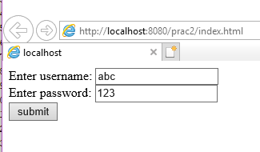

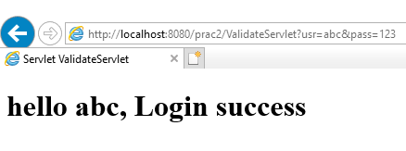

**Practical 1C**

**Aim**: Create a registration servlet in Java using JDBC. Accept the details such as Username, Password, Email, and Country from the user using HTML Form and store the registration details in the database.

**Program:**

***Index.html***

<!--

To change this template, choose Tools | Templates

and open the template in the editor.

-->

<!DOCTYPE html>

<html>

<head>

<title></title>

<meta http-equiv="Content-Type" content="text/html; charset=UTF-8">

</head>

<body>

<form action="RegistrationServlet">

Name:

<input type="text" name="usr" ><br>

Password:

<input type="text" name="pass" ><br>

Email:

<input type="text" name="email" ><br>

Country:

<input type="text" name="con" ><br>

<input type="submit" value="Submit"> &nbsp

<input type=“reset” value=”Clear”>

</form>

</body>

</html>

***RegistrationServlet.java***

import java.io.IOException;

import java.io.PrintWriter;

import javax.servlet.ServletException;

import javax.servlet.annotation.WebServlet;

import javax.servlet.http.HttpServlet;

import javax.servlet.http.HttpServletRequest;

import javax.servlet.http.HttpServletResponse;

import java.sql.*;

public class RegistrationServlet extends HttpServlet {

protected void processRequest(HttpServletRequest request, HttpServletResponse response)

throws ServletException, IOException

{

response.setContentType("text/html;charset=UTF-8");

PrintWriter out = response.getWriter();

try {

out.println("<!DOCTYPE html>");

out.println("<html>");

out.println("<head>");

out.println("<title>Servlet RegistrationServlet</title>");

out.println("</head>");

out.println("<body>");

String usr1 = request.getParameter("usr");

String pass1 = request.getParameter("pass");

String email1 = request.getParameter("email");

String con = request.getParameter("con");

try{

Class.forName("com.mysql.jdbc.Driver");

Connection con1 = DriverManager.getConnection("jdbc:mysql://localhost:3306/logindb","root","root");

PreparedStatement ptm = con1.prepareStatement("insert into tbluser value(?,?,?,?)");

ptm.setString(1, usr1);

ptm.setString(2, pass1);

ptm.setString(3, email1);

ptm.setString(4, con);

ptm.executeUpdate();

}catch(Exception se){

out.println("<h1> invalid details </h1>");

}

out.println("</body>");

out.println("</html>");

} finally {

out.close();

}

}

**Output :**

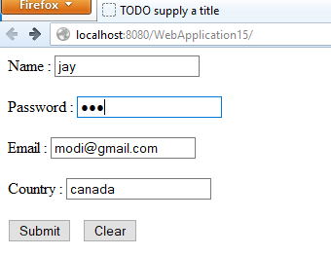

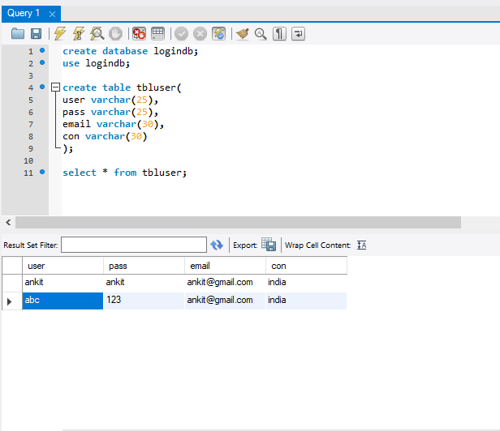

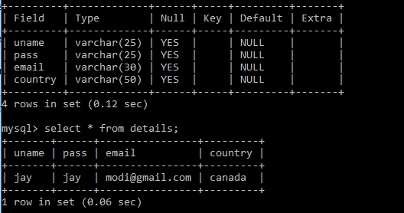

**Practical 2A**

**Aim**: Using Request Dispatcher Interface create a Servlet which will validate the password entered by the user, if the user has entered “Servlet” as password, then he will be forwarded to Welcome Servlet else the user will stay on the index.html page and an error message will be displayed.

**Program:**

***Index.html***

<html>

<head>

<title>TODO supply a title</title>

<meta charset="UTF-8">

<meta name="viewport" content="width=device-width, initial-scale=1.0">

</head>

<body>

<div>

<form action="LoginServlet">

Username <input type="text" name="uname"><br>

Password <input type="password" name="pass"><br>

<input type="submit" value="Submit"> &nbsp;

<input type="reset" value="Clear">

</form>

</div>

</body>

</html>

***LoginServlet.java***

package mypack;

import java.io.IOException;

import java.io.PrintWriter;

import javax.servlet.RequestDispatcher;

import javax.servlet.ServletException;

import javax.servlet.http.HttpServlet;

import javax.servlet.http.HttpServletRequest;

import javax.servlet.http.HttpServletResponse;

public class LoginServlet extends HttpServlet {

protected void processRequest(HttpServletRequest request, HttpServletResponse response) throws ServletException, IOException

{

response.setContentType("text/html;charset=UTF-8");

try( PrintWriter out = response.getWriter())

{

out.println("<!DOCTYPE html>");

out.println("<html>");

out.println("<head>");

out.println("<title>Servlet LoginServlet</title>");

out.println("</head>");

out.println("<body>");

String username = request.getParameter("uname");

String password = request.getParameter("pass");

if(username.equals("Admin")&&password.equals("Servlet"))

{

RequestDispatcher rd = request.getRequestDispatcher("WelcomeServlet");

rd.forward(request, response);

}

else

{

out.println("<h1>Invalid Login<h1>");

RequestDispatcher rd = request.getRequestDispatcher("index.html");

rd.include(request, response);

}

out.println("</body>");

out.println("</html>");

}

}

***WelcomeServlet.java***

package mypack;

import java.io.IOException;

import java.io.PrintWriter;

import javax.servlet.ServletException;

import javax.servlet.http.HttpServlet;

import javax.servlet.http.HttpServletRequest;

import javax.servlet.http.HttpServletResponse;

public class WelcomeServlet extends HttpServlet {

protected void processRequest(HttpServletRequest request, HttpServletResponse response) throws ServletException, IOException

{

response.setContentType("text/html;charset=UTF-8");

try (PrintWriter out = response.getWriter()) {

out.println("<!DOCTYPE html>");

out.println("<html>");

out.println("<head>");

out.println("<title>Servlet WelcomeServlet</title>");

out.println("</head>");

out.println("<body>");

String username = request.getParameter("uname");

out.println("<h1>Welcome "+username+"</h1>");

out.println("</body>");

out.println("</html>");

}

}

**Output:**

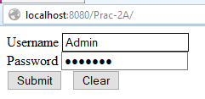

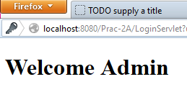

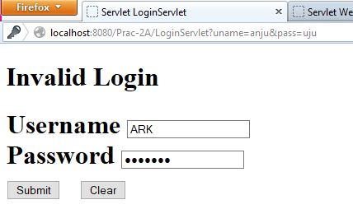

**Practical 2B**

**Aim**: Create a servlet that uses Cookies to store the number of times a user has visited servlet.

**Program code:-**

***Index.html***

<head>

<title>TODO supply a title</title>

<meta charset="UTF-8">

<meta name="viewport" content="width=device-width, initial-scale=1.0">

</head>

<body>

<h1 align="center">Cookies</h1>

<form action="cookiesServlet">

Enter your Name:<input type="text" name="name">

<input type="submit" value="cook">

<input type="reset">

</form></body>

***cookiesServlet.java***

package mypack;

import java.io.IOException;

import java.io.PrintWriter;

import javax.servlet.ServletException;

import javax.servlet.http.Cookie;

import javax.servlet.http.HttpServlet;

import javax.servlet.http.HttpServletRequest;

import javax.servlet.http.HttpServletResponse;

protected void processRequest(HttpServletRequest request, HttpServletResponse response)

throws ServletException, IOException

{

String name=request.getParameter("name");

response.setContentType("text/html;charset=UTF-8");

try (PrintWriter out = response.getWriter()) {

out.println("<!DOCTYPE html>");

out.println("<html><body>");

out.println("<h1>cookies Example</h1>");

out.println("<b>Welcome "+name+"</b>");

Cookie ck1=new Cookie("username",name);

Cookie ck2=new Cookie("visit","1");

response.addCookie(ck1);

response.addCookie(ck2);

out.println("<h1><a href=page2>Click to view next</a></h1>");

out.println("</body></html>");

}

}

***page2.java***

protected void processRequest(HttpServletRequest request, HttpServletResponse response)

throws ServletException, IOException {

Cookie[] ck=request.getCookies();

response.setContentType("text/html;charset=UTF-8");

try (PrintWriter out = response.getWriter()) {

out.println("<!DOCTYPE html>");

out.println("<html><body>");

for(int i=0;i<ck.length;i++){

if(ck[i].getName().equals("visit")) {

int count = Integer.parseInt(ck[i].getValue())+1;

out.println("<h1>Visit No: "+count+"</h1>");

ck[i]=new Cookie("visit",count+"");

response.addCookie(ck[i]); }

else

out.println(ck[i].getName()+" = "+ck[i].getValue());

} out.println("</body></html>");}}

**Output:**

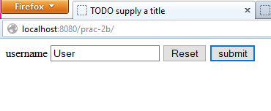

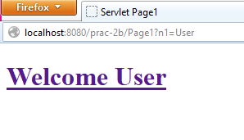

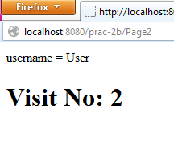

Top of Form

Bottom of Form